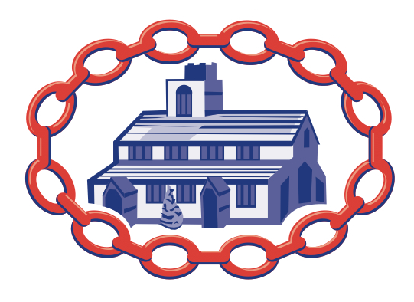
SAMLESBURY
Church of England School

PSHE Whole School Detailed Overview – 2 Year Plan 2019/2020 & 2020/2021

 | Autumn: Relationships |  |  | Spring: Living in the wider world |  |  | Summer: Health and Wellbeing
 | Families and  friendships | Safe relationships | Respecting ourselves and others | Belonging to a  community | Media literacy and  digital resilience | Money and work | Physical health and Mental wellbeing | Growing and changing | Keeping safe
Year 1&2 2019/2020 | Roles of different people; families; feeling cared for | Recognising privacy;  staying safe; seeking  permission | How behaviour  affects others; being polite and respectful | What rules are;  caring for others’  needs; looking after the environment | Using the internet  and digital devices;  communicating  online | Strengths and interests; jobs in the community | Keeping healthy;  food and exercise, hygiene routines; sun safety | Recognising what makes them unique  and special; feelings; managing when  things go wrong | How rules and age restrictions help us; keeping safe online
Year 1&2 2020/2021 | Making friends;  feeling lonely and getting help | Managing secrets; resisting pressure and getting help;  recognising hurtful behaviour | Recognising things in common and  differences; playing and working cooperatively; sharing opinions | Belonging to a  group; roles and  responsibilities;  being the same  and different in the community | The internet in  everyday life; online content and information | What money is;  needs and wants; looking after money | Why sleep is important; medicines and keeping healthy;  keeping teeth  healthy; managing feelings and asking for help | Growing older;  naming body parts; moving class or year | Safety in different  environments; risk and safety at home;  emergencies
Year 3&4 2019/2020 | What makes a  family; features of family life | Personal boundaries; safely responding to others; the impact of hurtful behaviour | Recognising respectful behaviour;  the importance of self-respect; courtesy and being polite | The value of rules and laws; rights, freedoms and responsibilities | How the internet is used; assessing  information online | Different jobs and skills; job stereotypes; setting personal goals | Health choices and habits; what affects feelings; expressing  feelings | Personal strengths and achievements;  managing and reframing setbacks | Risks and hazards; safety in the local  environment and unfamiliar places
Year 3&4 2020/2021 | Positive friendships,  including online | Responding to  hurtful behaviour;  managing confidentiality; recognising risks online | Respecting differences and similarities; discussing differences sensitively | What makes a  community; shared  responsibilities | How data is shared and used | Making decisions about money; using  and keeping money safe | Maintaining a balanced lifestyle; oral  hygiene and dental care | Physical and emotional changes in puberty; external  genitalia; personal hygiene routines;  support with puberty | Medicines and  household products;  drugs common to everyday life
Year 5&6 2019/2020 | Managing friendships and peer influence | Physical contact and feeling safe | Responding respectfully to a wide range of people; recognising prejudice and  discrimination | Protecting the environment; compassion towards others | How information  online is targeted;  different media  types, their role and impact | Identifying job interests and aspirations;  what influences  career choices;  workplace stereotypes | Healthy sleep  habits; sun safety;  medicines, vaccinations, immunisations  and allergies | Personal identity;  recognising individuality and different qualities; mental  wellbeing | Keeping safe in  different situations,  including responding  in emergencies, first aid
Year 5&6 2020/2021 | Attraction to others; romantic relationships; civil partnership and marriage | Recognising and  managing pressure; consent in different  situations | Expressing opinions and respecting  other points of view, including discussing  topical issues | Valuing diversity;  challenging discrimination and stereotypes | Evaluating media sources; sharing  things online | Influences and  attitudes to money; money and financial  risks | What affects mental  health and ways  to take care of it; managing change, loss and bereavement; managing time online | Human reproduction and birth;  increasing independence; managing  transition | Keeping personal  information safe; regulations and choices; drug use  and the law; drug use and the media

These topics will require reporting to parents so they have the opportunity to withdraw their child if they wish or ask questions.

