Samlesbury Church of England Primary School
Preventing and Managing Sickness including outbreaks
Risk Procedures and Risk Assessment

Progression of restrictions / Staged Response
At Samlesbury Church of England Primary School we have 4 stages for when dealing with medical incidents / outbreaks. Depending on the nature of the situation and stage

Response Stage | Trigger | Key Actions | Who | Notes
STAGE 1 – General  (everyday hygiene and procedures) | None | - General reminders for hygiene  - Effective handwashing facilities and soap available  - Follow usual absence periods for sickness
STAGE 2 – Prevention | Where an increased risk is present  - Increased absence rates of pupils or staff  - Local increases in sickness e.g. flu, gastric, coronavirus  - Public health alerts  - Suspected cases of specific illness in school or within the community (eg.coronavirus / gastric) | - Increase hygiene procedure  - Communication with key people including key information (staff, pupils and families, users of the site)  - Specific hygiene lessons in class  - Increased enforced use of handwashing before eating of food  - Enforce 48hr after symptoms have stopped for all fever, sickness, diarrhoea etc.  - Consider the types of trips and events and make changes as necessary (e.g. those where lots of close contact / touch points)  - Review Core Control Measures and make changes as necessary  - Daily review of the situation | HT/AHT  Admin  Staff
STAGE 3 – Mitigate/ Delay | Where a significant risk is present  - direct case or increased likelihood of cases  - Public health advice for restrictions | Consider reducing contact situations:  - Assemblies  - Carpet time  - School events  - Trips  Consider:  - Sending home any children with any symptoms  - Additional Cleaning including deeper cleans on public health advice | All staff
STAGE 4 – Containment | Where specific and/or significant changes or restrictions need to be in place.  - High levels of sickness  - High rates of absence  - Significance of danger of disease or illness | - Part / full closures of site / classes  - Deep cleans  - Closure of lettings and building use  - Reduction or exclusion of visitors  - Follow public health advice. | HT / Chair of Governors

Coronavirus Key Actions (as situation escalates)
Specific Issue | Actions including messages | Who | Notes
Confirmed case in school | - Deep clean core areas  - Inform staff  - Core reminders of hygiene  - Contact parents – general information about sickness etc. and the key next steps e.g. closure of a class / school/ or carry on etc.  - Phone: 0800 046 8687 Dfe helpline number | HT/AHT  Site
Confirmed case in a family | - Children in the family to remain at home for a fixed period of time  - Deep clean of the classroom and school  - Phone: 0800 046 8687 Dfe helpline number | HT/AHT  Site
Teacher shortage | - Supply / Splitting classes / HT cover  - Where too many – partial closure for certain classes or part time / AM / PM classes | HT/AHT
Support staff shortage | - Supply / Prioritise most needy children / classes with remaining staff | HT/AHT
Protection for most vulnerable children | - Identify who these children are vulnerable e.g. underlying health conditions that may be affected by the current threat  - Discuss with parents the initial steps and agree key actions re. isolation/seclusion | SEND lead/HT
Staff with health issues (e.g. Heart) | - Ask them to contact their consultants to seek advice on their condition  - Consider working from home | Staff
Staff with symptoms | - Stay at home; follow NHS 111 advice; discuss with HT | HT
Pregnant staff | - Ask them to contact their midwife to seek advice;  - Consider working from home | HT/AHT
Kitchen shut down | - Parents to provide packed lunches | HT/AHT  Families
Site team shortage | - Discuss with cleaning contractor cover arrangements in good time | Site
Leadership shortage | - Access via phone | HT/AHT  Staff
Admin shortage | - Cover with TAs / HT  - Inform parents not to phone unless emergency | staff
Other school users | - Inform of control measures, including the possibility that a suspension or usage may occur. | Site
Long period shut down | - Continue learning activities through Purple Mash, SATs Companion, TT rock stars, BBC online resources etc. School to provide staff with parents’ emails with permission so that staff can set work from home via email where possible.  - Children in Year 6 to use study guides.  - Provide children with book to write in, pencil and pen | HT/AHT  Staff

Core Control Measures
Control Measure | Control Stage | Notes / Action | Who | Review
Tissues for Each Class | 1 | - Ensure adequate stock levels of tissues for each class / office  - Replenish as needed  - Staff to also self-replenish from stock | Site; Staff
Alcohol based gel  (adults only)  Antiseptic wipes in all rooms | 1 | - Dispenser in staff toilets and in school kitchen for cook  - Ensure dispensers and full from the start of each day  - Ensure adequate stock levels | Site; Staff; Lunch Staff
Increase hand washing facilities | 1 | - First thing in morning on arrival  - Straight after break  - Before lunch  - After lunch  - 1 time half way through the afternoon | Site
Other users of the building | 2, 3 | Contact every user and inform them of usage expectations:  - Clean hands or use gel before using facilities  - Restrictions or suspensions of usage | Site
Monitoring daily any child or staff absence | 2 | - Daily report to the HT or number of absences and symptoms | Admin; HT
finding out about travel arrangements now and in the future of staff and pupils | 3 (where specific threats are evident aboard) | Newsletter:  - Ask parents to inform us of any close family member who has returned from abroad within the last month  - Staff members to inform SLT of any travel arrangements to high-risk areas including those of any close friends or family they have been in contact with. | Admin; HT
Reducing contact point activities | 2 | Ensuring extremely high hygiene for any  - Food making / tasting  Other  - Cease hand shaking of children and visitors  - Remind children not to share drinks bottles  - Ask every child to bring in a water bottle and take it home everyday | Staff
Good Personal Hygiene | 2 | Newsletter:  - Inform parents of hygiene expectations and to discuss with children;  - All children to wash their hands before coming to school, before going home and when they get home.  - Classes to teach children hand washing techniques  - Children to wash hands before snack (classroom) and before eating dinner (classrooms/ hall corridor toilets / hand sanitiser) | HT; Staff
Review of cleaning | 2, 3 | - Meet with cleaning staff to review cleaning arrangement and make any necessary changes (already done)  - Increase focus cleaning on touch points and tables  - Daily cleaning of classrooms (already in place)  - Preparations for deep cleans if necessary | Site; Cleaning Contractor
School visitors and site users | 2, 3 | - Inform them of schools prevention routines  - Informing us of any suspected or confirmed cases by any users | Office;  Site
Absence policy | 2 , 3 | - Review time period of absence for ill children or staff and increase if necessary but at least to the minimum standard (e.g. 48 hrs clear of sickness / diarrhoea | HT/AHT
Support for families affected | 2, 3 | - Communicate to parents and staff to contact school if they require support;  - Regular contact with affected families and staff – wellbeing checks. | HT/AHT  Kitchen staff

Samlesbury Church of England Primary School
Preventing and Managing Sickness
Information for staff, visitors and building users
STAGE 2 - PREVENTION

We have currently increased precautions in place to ensure effective prevention of the spread of illness.
All users of the building are asked to follow the following guidance:

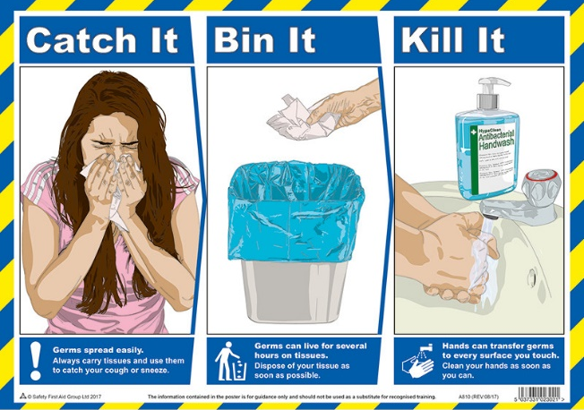
Do
- wash your hands with soap and water often – do this for at least 20 seconds
- always wash your hands when you get home or into work
- use hand sanitiser gel if soap and water are not available
- cover your mouth and nose with a tissue or your sleeve (not your hands) when you cough or sneeze
- put used tissues in the bin straight away and wash your hands afterwards
- try to avoid close contact with people who are unwell

Don't
- do not touch your eyes, nose or mouth if your hands are not clean
If you think you might have coronavirus, have been to a country or area with a high risk of coronavirus in the last 14 days or you've been in close contact with someone with coronavirus ring NHS 111. Visit https://www.nhs.uk/conditions/coronavirus-covid-19/ for further details.

Samlesbury Church of England Primary School
Preventing and Managing Sickness
Information for staff, visitors and building users
STAGE 3 - MITIGATE/ DELAY

We have currently increased precautions in place to ensure effective prevention of the spread of illness.
All users of the building are asked to follow the following guidance:

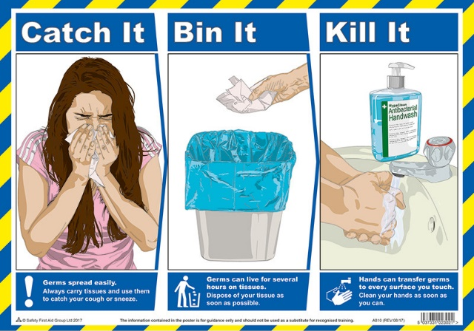
Do
- wash your hands with soap and water often – do this for at least 20 seconds
- always wash your hands when you get home or into work
- use hand sanitiser gel if soap and water are not available
- cover your mouth and nose with a tissue or your sleeve (not your hands) when you cough or sneeze
- put used tissues in the bin straight away and wash your hands afterwards
- try to avoid close contact with people who are unwell

Don't
- do not touch your eyes, nose or mouth if your hands are not clean
- enter the school if you are feeling unwell or have been in close contact with any person who is unwell (staff should contact the head teacher to discuss).

If you think you might have coronavirus, have been to a country or area with a high risk of coronavirus in the last 14 days or you've been in close contact with someone with coronavirus ring NHS 111. Visit https://www.nhs.uk/conditions/coronavirus-covid-19/ for further details.

